Screenshots

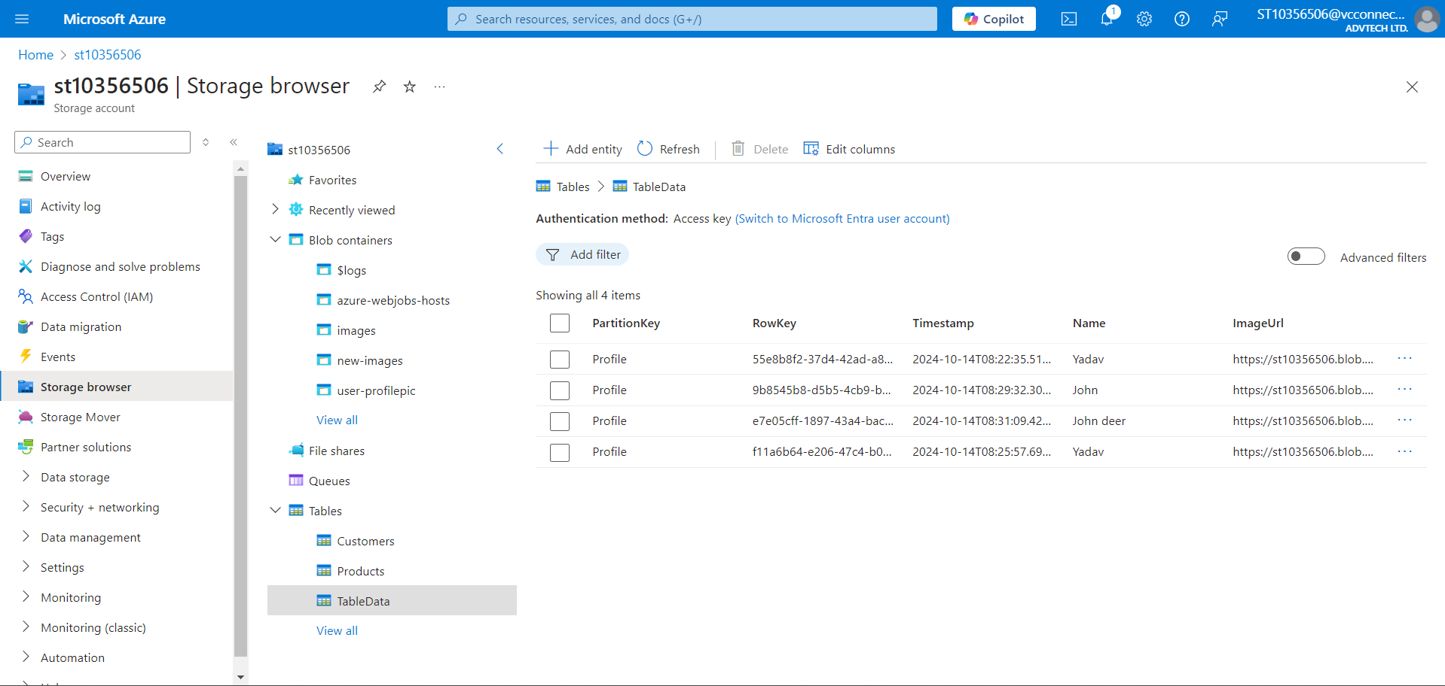

url: <https://ice2-fwcdhucrf3c8h6av.koreacentral-01.azurewebsites.net/>